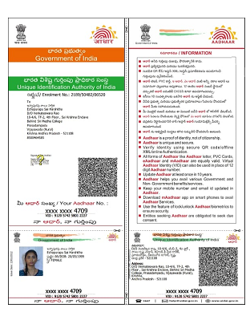

linkedin.com/in

/sai-harshitha-echapurapu/

Sai Harshitha Echapurapu
Big Data Engineer

Dedicated IT professional with history of meeting company goals utilizing consistent and organized practices. Initiative-taking with a strong adherence to personal accountability in both individual and team scenarios. Skilled in working under pressure and adapting to new situations and challenges to best enhance the organizational brand.

Work History
Contact

Address
Vijayawada, India 521108

Phone
8500464585
E-mail harshithaechapurapu@gm ail.com

2021-01 -
Current
Big Data Engineer
Tata Consultancy Services, Hyderabad

Responsibilities:
Work with project teams to identify, define, document, and communicate data Ingestion requirements.
Led team of 11, ensured in delivering work in time.
Generated metadata documents to load incoming data into HDFS
Experienced in working with spark ecosystem using Spark SQL on different formats like text file, CSV file
Responsible for Data extraction and data ingestion from different data sources into HDFS by crafting ETL pipelines using Hive and Spark Created Hive Schemas using performance techniques like partitioning and bucketing
First hand experience with Big data tools like Hadoop, Spark, Hive
Working on Bitbucket for building and deploying code into repository.
Used GIT for Version Control
Integrally involved in scheduling Daily, Weekly, Monthly jobs with Precondition/PostCondition based on requirements
Automate data flow using Control-M Scheduler Monitor Daily, Weekly, Monthly jobs and provide
support in case of failures/issues

LinkedIn
linkedin.com/in
/sai-harshitha-echapurapu/

Skills

Programming Languages: Python, Shell Scripting
Databases: MYSQL Informatica
Big Data Framework: Hadoop, Spark, Hive, Kafka
Control Systems and Documentation: Git, GitHub, Bitbucket, Jira, Confluence
Scheduler: Control-M

Design, Develop and Test ETL Mappings, Mapplets, Workflows, Worklets using Informatica Power Center
Monitored transformation processes using Informatica Workflow monitor
Created UNIX shell scripts to run Informatica workflows and controlling ETL flow Proficiency in developing SQL with various relational databases like Oracle, SQL Server
Written and executed Test Cases and reviewed with Business and Development Teams Involved in change management activities for promoting code to Production

Education

2016-06 -
2020-10

Bachelor of Technology: Computer Science Engineering
NRI Institute of Technology - Vijayawada,India

Certifications

Microsoft Certified: Azure Fundamentals(AZ-900)

Edureka Certified: Apache Spark developer using Python
Edureka Certified: Big Data Expert

